1. Create two instance in different zone of ap-south-1

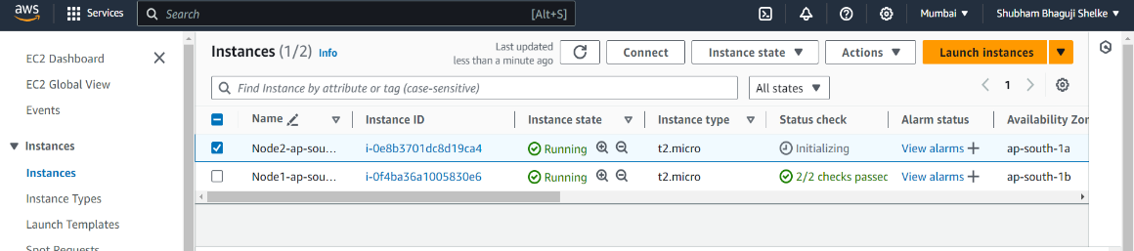

1. Create load balancer for running two instances

Classic load balancer

